**TagViz**

User manual

**Abstract**

TagViz is a data visualization tool that enables analysis of genomic sequencing data. The software includes a highly interactive user interface and graphing tools with multiple options for customizing the graph. The software also includes utilities for uploading data and exporting the resulting graph in different formats.

This document contains the manual of how to use TagViz. The rest of the document is ordered as follows: Chapter 1 contains explanation of how to upload and manage data. Chapter 2 includes instructions for graphing and setting graph preferences. Chapter 3 introduces editing tools. Chapter 4 describes how to export graphs. Chapter 5 discusses other system functionality and features.

This document related to the functionality of TagViz v. 1.2 as of 11 April 2014.

Table of Contents

1 Data Management 5

1.1 Data types 5

1.1.1 File format 5

1.1.2 Sample file structure 5

1.1.3 Group file structure 6

1.2 Uploading data 6

1.2.1 Open sample 6

1.2.2 Open group 7

1.3 Searching data 9

1.4 Deleting data 9

1.4.1 Delete sample 9

1.4.2 Delete group 10

2 Graphing 12

2.1 Generating a graph 12

2.2 Editing graph 13

2.2.1 Graph type 14

2.2.2 Graph legend 14

2.2.3 Graph symbol 14

2.3 Editing colors 14

2.3.1 Colors 14

2.3.2 Series colors 15

2.4 Editing text and fonts 15

2.4.1 Graph title 16

2.4.2 X-Axis label 16

2.4.3 Y-Axis label 17

2.4.4 Axes font 17

2.4.5 Tick labels font 17

2.4.6 Legend labels font 17

2.5 Editing grid and lines 18

2.5.1 Axes tick labels 19

2.5.2 Axes tick marks 19

2.5.3 Axes tick interval 19

2.5.4 Axes tick max count 19

2.5.5 Axes gridlines 20

2.5.6 Tick width and length 20

2.5.7 Series line width 20

2.6 Editing scale 21

2.6.1 X-axis scale 21

2.6.2 Y-axis scale 21

3 Graphing tools 22

3.1 Tools overview 22

3.2 Move tool 22

3.3 Draw tool 22

3.3.1 Drawing a line 22

3.3.2 Deleting a line 22

3.4 Write tool 22

3.4.1 Creating text 23

3.4.2 Moving text 23

3.4.3 Deleting text 23

4 Exporting graphs 24

4.1 Export overview 24

4.2 Export as PNG 24

4.3 Export as PDF 24

4.4 Show export 25

5 Other functionality 26

5.1 Saving preferences 26

5.2 Sidepanels visibility 26

5.2.1 Show sidepanels 26

5.2.2 Hide sidepanels 26

5.2.3 Hide data panel only 26

5.3 Errors 26

# Data Management

## Data types

TagViz accepts data as a sample file or a group file. Sample and group files have to conform to specifications of acceptable file format and acceptable file structure.

### File format

Acceptable upload file formats are gzipped (.gz), text (.txt) or group (.group)

### Sample file structure

Sample file uses newline character as a row separator and tab as a column separator. There has to be the same number of columns for each row. The number of rows is not limited. The first row describes the data headers and will be used to populate the graph axes. All subsequent rows describe features and contain the plot data.

Figure 1.1 displays a simplified example of sample file structure. TagViz data parser will interpret sample columns as follows:

1. Feature name

2. Feature chromosome (type string)

3. Start value (type int)

4. End value (type int)

5. Ignored column

6…n Feature data (type double)

Figure 1.1. Example of sample file

|  |  |  |  |  |  |  |  |  |
| --- | --- | --- | --- | --- | --- | --- | --- | --- |
| #Gene | Ref | Start | End | Strand | -5000 | -4980 | -4960 | -4940 |
| CpG2400 | chr1 | 1167000 | 1168985 | . | 1.844 | 1.800 | 1.862 | 1.895 |
| CpG2753 | chr1 | 1173914 | 1174263 | . | 1.929 | 2.072 | 2.156 | 2.211 |
| CpG29 | chr1 | 327789 | 328229 | . | 0 | 0 | 0 | 0 |
| CpG94 | chr1 | 533218 | 534114 | . | 0.161 | 0.161 | 0.161 | 0.161 |

### Group file structure

Group file includes list of feature names separated by tab character. Figure 1.2. shows an example of group file structure. The purpose of the group file is to allow easy creation of subsets of features and calculating the average of the subset data. Therefore user should upload sample files before group files.

TagViz parser will read the contents of the group file and look for matches in the names of existing features. TagViz will ignore group file if it does not match any existing features.

Figure 1.2. Example of group file structure.

21:NM_152486:SAMD11 22:NM_015658:NOC2L 23:NM_198317:KLHL17 28:NM_001142467:HES4 30:NM_198576:AGRN 32:NM_017891:C1orf159 39:NM_004195:TNFRSF18 41:NM_148902:TNFRSF18 45:NM_080605:B3GALT6 43:NM_016176:SDF4 44:NM_016547:SDF4 46:NM_001014980:FAM132A

## Uploading data

### Open sample

To upload a sample, navigate to the top menu bar and select:

*File > Open Sample*

Clicking on the menu option will generate the window illustrated in Figure 1.3.

Figure 1.3. Open Sample

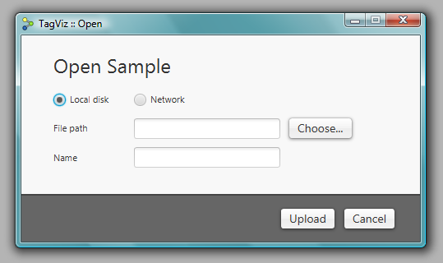

If your sample file is hosted on your local disk use the “Choose..” button to navigate to the sample. If your sample is hosted on a network server, select the network radio button, and copy paste the URL of the sample file into the text field.

TagViz will automatically populate the sample name field, but if you wish to rename the sample and how it should appear in the system, enter the desired name in the name field. Finally, press the upload button.

After pressing upload TagViz will attempt to retrieve and parse the requested file. A blue progress bar will appear in the interface to indicate upload process is being handled. After a sample is successfully read, the sample and its features will appear in the user interface as shown in Figure 1.4.

Figure 1.4. Processed sample

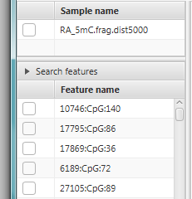

### Open group

To upload a group, navigate to the top menu bar and select:

*File > Open Group*

Clicking on the menu option will generate the window illustrated in Figure 1.5.

Figure 1.5. Open Group

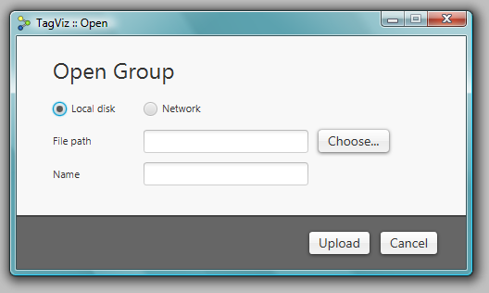

If your group file is hosted on your local disk use the “Choose..” button to navigate to the group file. If your group file is hosted on a network server, select the network radio button, and copy paste the URL of the group file into the text field.

TagViz will automatically populate the group name field, but if you wish to rename the group and how it should appear in the system, enter the desired name in the name field. Finally, press the upload button.

After pressing upload TagViz will attempt to retrieve and parse the requested file. A blue progress bar will appear in the interface to indicate upload process is being handled. After a group is successfully read, the group will appear in the user interface as shown in Figure 1.6.

Figure 1.6. Processed group

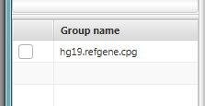

## Searching data

TagViz enables searching through uploaded features using a search function. To use this feature, navigate to the left of the interface, and look for a bar with label “Search features”. Clicking on the bar will toggle the visibility of the search field. The search field is displayed in Figure 1.7.

Figure 1.7. Search feature

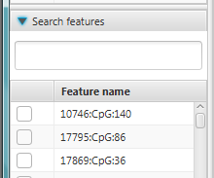

To search for specific features, type a text into the search field and press ENTER. TagViz will search for matches in feature whose name contains the substring entered into the search field.

To clear the search results and redisplay the full list of features, either delete the input from the search field and press ENTER, or click on the “Search features” bar. The latter will also hide the search field.

## Deleting data

### Delete sample

To delete a sample, navigate to the top menu bar and select:

*File > Delete Sample*

If there are no uploaded samples this option is disabled. Therefore uploading a sample is required before it can be deleted. Clicking on the “Delete Sample” menu item will generate the window displayed in Figure 1.8.

Figure 1.8. Delete Sample

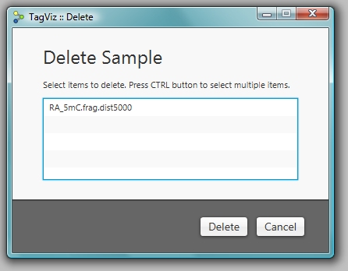

To delete a sample, click on the sample name and press delete. To delete multiple samples, hold down CTRL on the keyboard, click on one or more sample names, and press delete.

After pressing the delete button TagViz will process the selection and delete the selected samples. The user interface will update and the sample and the features contained in the sample will no longer be visible in the lists of samples and features.

The list of feature names is a union of all features contained in the uploaded samples. Therefore if the same feature name exists in multiple samples, it will continue to display even if one of the samples is deleted. A feature name will be deleted when there are no references to it in the list of samples.

### Delete group

To delete a group, navigate to the top menu bar and select:

*File > Delete Group*

If there are no uploaded groups this option is disabled. Therefore uploading a group is required before it can be deleted. Clicking on the “Delete Group” menu item will generate the window displayed in Figure 1.9.

Figure 1.9. Delete Group

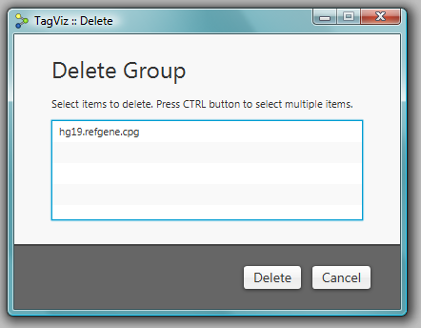

To delete a group, click on the group name and press delete. To delete multiple groups, hold down CTRL on the keyboard, click on one or more group names, and press delete.

After pressing the delete button TagViz will process the selection and delete the selected groups. The user interface will update and the selected groups will no longer be visible in the lists of groups.

# Graphing

## Generating a graph

Generating a graph requires some data is first uploaded into the system. TagViz allows graphing a selection of samples, features, and groups.

To generate a graph navigate to the left of user interface and select the data items you wish to graph. Select one or more items from by clicking on the checkbox next to its name. Figure 2.1. illustrates selecting two features. To deselect a data item click on the checkbox again until the checkmark disappears.

Figure 2.1. Selecting data items

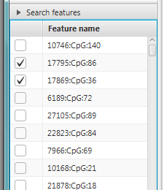

After selecting one or more items, click on the “Draw” button in the top left corner. A graph will appear in the center graphing panel as shown in Figure 2.2.

Figure 2.2. Generated graph

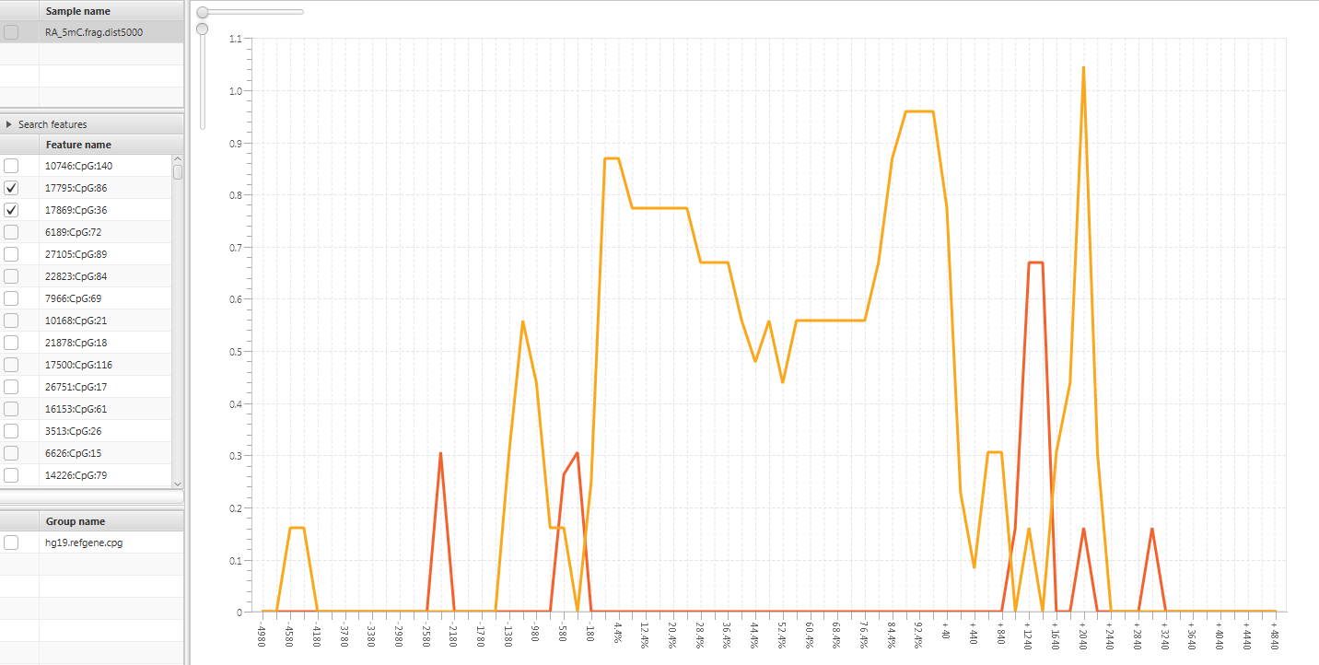

## Editing graph

TagViz allows customizing several aspects of the graph. Figure 2.3 displays the menu to control graph preferences.

Figure 2.3. Graph preferences menu

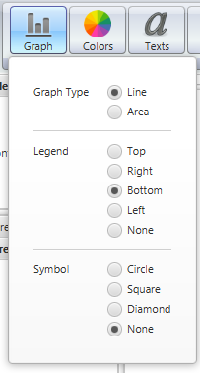

### Graph type

TagViz support two types of graphs: line and area. An area graph also includes a fill color, while line graph shows only a line. To change the type of graph navigate to:

*Preferences > Graph > Graph type*

Graph type will change as you change the current selection.

### Graph legend

TagViz allows customizing the position of the legend. The possible options are top, bottom, left, right, or none. Selecting none means no legend will be displayed.  
To change the legend position navigate to:

*Preferences > Graph > Legend*

Graph legend will change as you change the current selection.

### Graph symbol

TagViz allows customizing a data series symbol. Symbol appears along the graph data plot. The possible options are circle, square, diamond, or none. Selecting none means no symbol will be displayed. To change the symbol navigate to:

*Preferences > Graph > Symbol*

Graph symbol will change as you change the current selection.

## Editing colors

### Colors

TagViz allows customizing graph colors. You can change the following options: drawing area (graph background), graph area (plot background), graph border, graph title color, axes labels color, legend labels, legend background, x-axis gridlines, y-axis gridlines, tick labels (along axes), tick lines (along axes), symbol fill. These values can be set to any color in the RGB range. The graph colors menu is shown in Figure 2.4. To change any of the color options navigate to:

*Preferences > Colors*

Graph colors will change as you change the current selection.

Figure 2.4 Graph colors menu

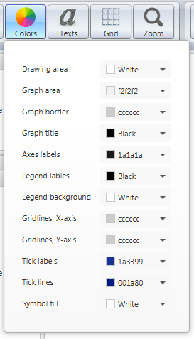

### Series colors

TagViz also allows customizing data series colors. To change a plot color, hover over the specific series line or area, which will change the mouse cursor to a hand. Then right click on the mouse and a context menu will appear. For line graph there is an option to change the line color. For an area graph there is an option to change the line color and area fill color. Changing the current selection will change the series color respectively.

## Editing text and fonts

TagViz allows setting and changing graph title and axes labels. These are all optional and can also be left blank. Figure 2.5. shows the menu for editing text and fonts.

Figure 2.5 Graph text menu

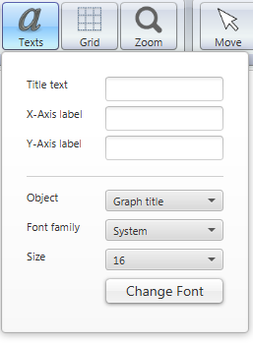

### Graph title

TagViz allows customizing graph title. To set or change the graph title navigate to:

*Preferences > Texts > Title text*

Type text in the text field and press ENTER. Graph title will change after pressing the ENTER key.

To change graph title font, navigate to:

*Preferences > Texts > Object > Graph title*

If or once the object is set to graph title, you will see the current settings for title font in the “Font family” and “Size” comboboxes. Font family lists all fonts found in your system, and sizes a preconfigured to range between 6-57 pixels. To change the settings select a font family and/or font size and press “Change font” button. Graph title will update after the button is clicked.

### X-Axis label

TagViz allows customizing x-axis label. To set or change the x-axis label navigate to:

*Preferences > Texts > X-Axis label*

Type text in the text field and press ENTER. X-axis label will change after pressing the ENTER key.

### Y-Axis label

TagViz allows customizing y-axis label. To set or change the y-axis label navigate to:

*Preferences > Texts > Y-Axis label*

Type text in the text field and press ENTER. Y-axis label will change after pressing the ENTER key.

### Axes font

TagViz allows customizing axes fonts. The axes fonts are controlled by the same variable and therefore cannot be set to different values for each axis.

To change the axes font navigate to:

*Preferences > Texts > Object > Axes*

If or once the object is set to Axes, you will see the current settings for axes font in the “Font family” and “Size” comboboxes. Font family lists all fonts found in your system, and sizes a preconfigured to range between 6-57 pixels. To change the settings select a font family and/or font size and press “Change font” button. Axes will update after the button is clicked.

### Tick labels font

Tick labels are texts that appear along the axes. TagViz allows customizing tick labels fonts. The axes fonts are controlled by the same variable and therefore cannot be set to different values for each axis. To change the tick labels font navigate to:

*Preferences > Texts > Object > Tick labels*

If or once the object is set to Tick labels, you will see the current settings for tick labels font in the “Font family” and “Size” comboboxes. Font family lists all fonts found in your system, and sizes a preconfigured to range between 6-57 pixels. To change the settings select a font family and/or font size and press “Change font” button. Tick labels will update after the button is clicked.

### Legend labels font

Legend labels are texts that appear inside the graph legend. TagViz allows customizing legend labels fonts. To change the legend labels font navigate to:

*Preferences > Texts > Object > Legend labels*

If or once the object is set to Legend labels, you will see the current settings for legend labels font in the “Font family” and “Size” comboboxes. Font family lists all fonts found in your system, and sizes a preconfigured to range between 6-57 pixels. To change the settings select a font family and/or font size and press “Change font” button. Legend labels will update after the button is clicked.

## Editing grid and lines

TagViz allows customizing graph grid lines, tick marks and labels visibility, tick interval and max count, and tick width and length. The width of each data series line can also be customized.

Figure 2.6 Grid menu

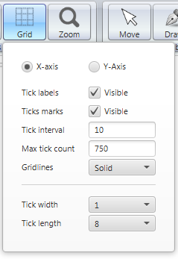

TagViz allows customizing several properties of the axes and these options are listed under grid menu shown in Figure 2.6. To change x-axis options first check that X-axis radiobox is selected, then proceed to change the options. To change y-axis options first check that Y-axis radiobox is selected, then proceed to change the options.

### Axes tick labels

Axes tick labels are text that appear along a specified axis. TagViz allows customizing the visibility of tick labels individually for each axis.

To toggle tick labels visibility, navigate to:

*Preferences > Grid > tick labels*

Tick labels will be visible when the checkbox is checked.

### Axes tick marks

Axes tick marks are lines that appear along a specified axis. TagViz allows customizing the visibility of tick labels individually for each axis.

To toggle tick marks visibility, navigate to:

*Preferences > Grid > tick marks*

Tick marks will be visible when the checkbox is checked.

### Axes tick interval

Tick interval controls the number of data values that will be graphed. For example if a data item contains 100 values and tick interval is set to 2, graph will draw every even value. The lower the interval and the higher the number of values, the longer it takes to generate the graph.

TagViz allows customizing the tick interval individually for each axis. To change tick interval, navigate to:

*Preferences > Grid > tick interval*

Enter a number in range 1-999 and press enter to change tick interval.

### Axes tick max count

Tick max count controls the number of data plot points. The plot item number will not exceed the specified number of tick max count. If data item contains more values than the given maximum, the interval will adjust accordingly. The max count has precedence over tick interval setting. The lower the interval and the higher the number of values, the longer it takes to generate the graph.

TagViz allows customizing the tick max count individually for each axis. To change tick max count, navigate to:

*Preferences > Grid > tick interval*

Enter a number in range 1-999 and press enter to change tick interval.

### Axes gridlines

Gridlines are horizontal and vertical lines in the graph area background. TagViz allows customizing the appearance of gridlines individually for each axis. To change the gridlines navigate to:

*Preferences > Grid > Gridlines*

Select an option from the dropdown menu. Changing the current selection will update the setting.

### Tick width and length

Axes ticks are lines and associated labels that appear along an axis. TagViz allows customizing the width and length of tick marks. This option is controlled by the same variable therefore changing this option applies to both axes.

To change tick width, navigate to:

*Preferences > Grid > Tick width*

Select and option from the dropdown menu and graph axes tick lines with will update accordingly.

To change tick length, navigate to:

*Preferences > Grid > Tick length*

Select and option from the dropdown menu and graph axes tick lines with will update accordingly

### Series line width

TagViz also allows customizing data series width. To change a series line width, hover over the specific series line or area, which will change the mouse cursor to a hand. Then right click on the mouse and a context menu will appear. Change the line width and the series line width will change accordingly.

## Editing scale

TagViz allows customizing the axis scale. The scale can be changed individually for each axis. The scale range is 1-2.5 and defaults to 1. When scale value is set to one the size of the graph fills the graph panel width and height with no overlap.

Figure 2.7. Axis scale sliders

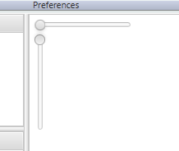

### X-axis scale

X-axis scale can be changed by hovering over the horizontal x-axis slider. Click on the control ball and drag mouse left or right to change the value. Graph x-axis scale will adjust accordingly.

### Y-axis scale

Y-axis scale can be changed by hovering over the vertical y-axis slider. Click on the control ball and drag mouse up or down to change the value. Graph y-axis scale will adjust accordingly.

# Graphing tools

## Tools overview

TagViz provides multiple tools for further edit the appearance of a generated graph. To use these tools, user must first upload sample data and generate a graph. The tools are located in the control bar on top of the user interface, as show in figure 3.1.

Figure 3.1 Editing tools

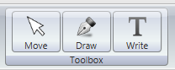

## Move tool

The move to allows moving a graph once its size exceeds the size of the graphing area. To enable the move tool, click on the move button. When move tool is enabled, hovering over the graph will show a hand cursor.

## Draw tool

Draw tool allows free-hand drawing over the graph area. To enable the draw tool, click on the draw button. When draw tool is enabled, hovering over the graph will show an arrow cursor.

### Drawing a line

To begin drawing press down on the left mouse button and continue to keep it down as you drag along the graph area. To stop drawing release the mouse button.

### Deleting a line

To delete a path right-click the mouse over it.

## Write tool

Write tool allows adding custom texts over and around the graph area. To enable the write tool, click on the write button. When write tool is enabled, hovering over the graph will show a text cursor.

### Creating text

To begin writing, click somewhere on the graph area. TagViz will generate a text field width gray border and prompt text “Enter text” as shown in Figure 3.2. Change the text value by clicking on the field and typing, as shown in Figure 3.3. A finished label will show the text on a transparent background, as shown in Figure 3.4.

Figure 3.2. Created text field



Figure 3.3. Entering text



Figure 3.4 Final appearance



The size of the text field is fixed, but you can add unlimited number of labels. To extend the size of apparent text field, add multiple labels and align them appropriately.

### Moving text

You can move labels to any position by hovering over the text border and dragging it along the graph area.

### Deleting text

You can delete a text field by right-clicking the mouse over it.

# Exporting graphs

## Export overview

TagViz allows saving a generated graph as an image or as a pdf file. The function will save an exact image of what is in the graph area excluding the scaling bars shown in Figure 2.7. This means it includes any changes to axes scaling and application of draw and write tools.

## Export as PNG

This feature will save an image of the generated graph. To being export, navigate to the top left menu bar and select:

*File > Export Graph > Export As PNG*

Clicking on the option will display a file chooser dialog that request a file name and file type. File type is preset to PNG and there are no other options. File name can be set freely. After setting the filename click “Save”. TagViz will then generate a snapshot of the graph area and save it as PNG image in the specified location.

The dimensions of the generated image are relative to the actual size of the graph area.

## Export as PDF

This feature will save a pdf file of the generated graph. To being export, navigate to the top left menu bar and select:

*File > Export Graph > Export As PDF*

Clicking on the option will display a file chooser dialog that request a file name and file type. File type is preset to PDF and there are no other options. File name can be set freely. After setting the filename click “Save”. TagViz will then generate a snapshot of the graph area and save it as a pdf file in the specified location.

The pdf document defaults to 1-page letter size. If the graph width exceed its heights, the generated pdf will be landscape, else it will be portrait. If the graph is scaled and the size of the graph exceeds the size of 1 letter page, the graph will scale down to fit the page size.

## Show export

TagViz enables setting an option to launch a generated PNG or PDF file upon export. This option is located in the menu bar, and can be change by navigating to:

*File > Export Graph > Display file*

If the checkbox is checked, TagViz will open an exported file automatically upon completion of the export function. If the checkbox is not checked, TagViz will generate the file but not open it for preview.

# Other functionality

## Saving preferences

TagViz will automatically save graph preferences such as graph type, colors, fonts etc. This functionality is enabled by default and will execute whenever preferences are changed. The settings will be saved in the same file where the executable application is saved, so it is advisable to save the application in a writable directory. The preferences are saved in a file titled “settings”. If this file is deleted or corrupted, graph preferences are set to their defaults.

## Sidepanels visibility

To enhance analyzing the graph, it is possible to toggle the visibility of both data panels on the left and control bar on top of the user interface.

### Show sidepanels

To hide both panels, press CTRL+1, or use the top menu bar and navigate to:

*View > Collapse Sidepanels*

### Hide sidepanels

To show both panels, press CTRL+2, or use the top menu bar and navigate to:

*View > Show Sidepanels*

### Hide data panel only

To adjust the size and/or visibility of data panels only, bovver over the vertical separator between the data panels and the graph area, click and drag the mouse. Dragging to the left will reduce the width or hide the panel, and dragging to the right will increase its width.

## Errors

TagViz will generate error messages when invalid requests occur. The error message appears in the top right corner of the user interface. The error message includes a header and short description of the cause. Error messages fade automatically after a few seconds, or it can be hidden immediately by clicking on a “X” icon in the top right corner. Figure 5.1 shows a sample error message.

Figure 5.1. Error message

